Looking for a way to give back in 2022? Martha’s Kitchen would love to invite you to come and help us Feed the Hungry with Dignity.

The first step to volunteering is to register on our [Volunteer Website](https://marthaskitchen.galaxydigital.com/user/login/) and sign our electronic waiver. Once your waiver is signed, please choose a volunteer opportunity that best fits your schedule. If you have any issues finding the waiver, please choose an opportunity, and when you “respond” to it, you will automatically be redirected to the electronic waiver.

The minimum age to volunteer at Martha’s Kitchen without a parent or guardian is 15 years old. If you are under the age of 15, you can volunteer with a parent/guardian. Children under 12 years of age are not permitted to volunteer. If you need student hours verified, see me at the end of your shift.

We require COVID Vaccination cards for all volunteers at Martha’s Kitchen. Please email a pdf or photo of your card to [jennie@marthas-kitchen.org](mailto:jennie@marthas-kitchen.org). When you arrive, please verify with the office that your vaccination card is on record and receive a Martha’s Kitchen wristband to wear while volunteering. If you have any questions regarding our COVID policies, please reach out to me at any time.

Make sure to check out and read through the sign-up instructions found [HERE](https://marthaskitchen.galaxydigital.com/sign-up-instructions/). Then proceed to the website by clicking [HERE](https://marthaskitchen.galaxydigital.com/) to sign up. When you arrive at Martha's Kitchen, please check in using the QR code on the wall in the main hallway. Make sure also to wear closed-toed shoes and bring a hat. If you have any questions, please let me know.

We at Martha’s Kitchen look forward to partnering with you to ensure that no one goes to bed hungry.

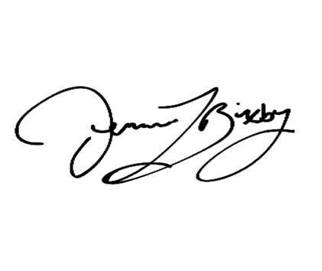

Jennie Bixby

Programs Manager

Martha’s Kitchen

311 Willow St.

San Jose, CA 95110

408-293-6111